SIMATS ENGINEERING ASSESSMENT TOOL 3
COURSE NAME: INTERNET PROGRAMMING
COURSE CODE: CSA43
Name: k .Rasool
Reg No:192372308
Question 1: Select the correct HTML tag for video embedding and justify your answer
Step 1: What is HTML?
HTML stands for HyperText Markup Language. It is used to create the structure of a webpage, including headings, paragraphs, images, videos, and links.
Step 2: What is the <video> tag?
The HTML <video> tag is used to display a video directly on a webpage without requiring a separate video player application.
Step 3: Understand the given options
Option | Tag | Explanation
A | <media> | Not a standard HTML video element.
B | <video> | Corect standard HTML element for embedding video.
C | <movie> | Not a standard HTML video element.
D | <vid> | Not a standard HTML video element.

Understand the code
<!DOCTYPE html>
<html>
<head>
<title>Video Example</title>
</head>
<body>
<h2>Welcome to Our Website</h2>
<video src="video.mp4" controls></video>
</body>
</html>
Expected output
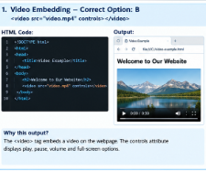

Question 2: Identify the appropriate HTTP method for form submission and explain why.
Correct answer: Option B — POST
Step 1: What is HTTP?
HTTP stands for HyperText Transfer Protocol. It defines how web browsers and web servers communicate with each other.
For example, when you open a website, your browser sends a request to the web server, and the server sends back a response.
Step 2: What is an HTTP method?
An HTTP method specifies the action that a client wants to perform on a server resource.
The given options are:
Method | Purpose
GET | Retrieves data from the server.
POST | Submits data to the server, often to create or process information.
PUT | Creates or replaces a resource at a specified location.
DELETE | Requests deletion of a resource.
Step 3: Why is POST suitable for registration?
Suppose a user registers on a website by entering:
- Username
- Email address
- Password
The website needs to send these details to the server for processing. The POST method sends the form data in the request body instead of placing it in the URL as GET commonly does.
Step 4: Example program
HTML
<!DOCTYPE html>
<html>
<head>
<title>Registration Form</title>
</head>
<body>
<h2>User Registration</h2>

<form action="/register" method="POST">
<label>Username:</label>
<input type="text" name="username">

<br><br>

<label>Email:</label>
<input type="email" name="email">

<br><br>

<label>Password:</label>
<input type="password" name="password">

<br><br>

<button type="submit">Register</button>
</form>
</body>
</html>
Step 5: How it works
Step 1: User enters details
Username, email and password
Step 2: Form uses POST
Data is sent in the HTTP request body
Step 3: Server processes the data
The server validates and processes the registration

Output:
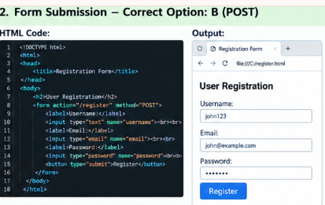
Question 3: Choose the proper semantic element for navigation and justify its usage.
Correct answer: Option B — <nav>
Step 1: What is a semantic HTML element?
A semantic HTML element describes the meaning or purpose of the content it contains.
Examples include:
- <header> — introductory content or a page header.
- <nav> — navigation links.
- <section> — a thematic section of content.
- <footer> — footer information.
Step 2: What is the <nav> element?
The <nav> element defines a section of a webpage containing important navigation links.
For example, a website may have links such as Home, About, Services, and Contact.
Step 3: Understand the given options
Option | Element | Purpose
A | <div> | General-purpose container without inherent semantic meaning.
B | <nav> | Correct element for a navigation section.
C | <section> | Groups related content into a section.
D | <header> | Represents introductory content or a header.
Step 4: Example program
HTML
<!DOCTYPE html>
<html>
<head>
<title>Navigation Menu</title>
</head>
<body>

<header>
<h1>My Website</h1>
</header>

<nav>
<a href="index.html">Home</a>
<a href="about.html">About</a>
<a href="services.html">Services</a>
<a href="contact.html">Contact</a>
</nav>

<h2>Welcome</h2>
<p>This is the homepage of our website.</p>

</body>
</html>
Step 5: Expected output
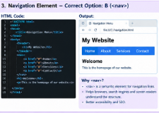

Question 4: Identify the correct XML syntax and explain the error in other options.
Correct answer: Option B — <note><to>User</to><from>Admin</from></note>
Step 1: What is XML?
XML stands for Extensible Markup Language. It is used to store, organize, and exchange structured data.
For example, a website or application may use XML to store configuration settings or information about users.
Step 2: Understand XML rules
XML follows these important rules:
- Every opening tag must have a matching closing tag unless it is written as a self-closing element.
- Tags must be properly nested.
- Opening and closing tag names must match exactly.
- XML documents must have one root element containing the other elements.
- Attribute values must be enclosed in quotation marks.
Step 3: Examine the given options
Option A
XML
<note><to>User</to><from>Admin</from>
Error: The opening <note> tag has no matching closing </note> tag.
Option B — Correct
XML
<note><to>User</to><from>Admin</from></note>
Explanation: All opening tags have matching closing tags, and the elements are correctly nested.
Option C
XML
<note><to>User</from></note>
Error: The <to> element is opened but incorrectly closed using </from>. The tag names do not match.
Option D
XML
<note to="User"></note
Error: The closing tag is incomplete because it is missing the final > character.
Step 4: Write the correct XML document
XML
<?xml version="1.0" encoding="UTF-8"?>

<note>
<to>User</to>
<from>Admin</from>
<message>Welcome to the website</message>
</note>
Step 5: Understand the output

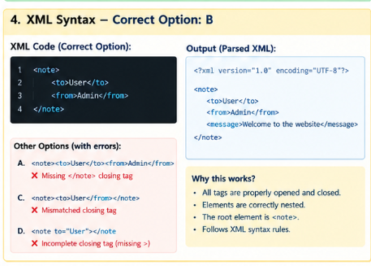
Question 5: Choose the correct protocol for web communication and justify your choice.
Correct answer: Option B — HTTP
Step 1: What is a communication protocol?
A communication protocol is a set of rules that devices follow to exchange information over a network.
Different protocols are designed for different purposes, such as accessing webpages, transferring files, and sending email.
Step 2: Understand the given options
Option | Protocol | Purpose
A | FTP | File Transfer Protocol, used to transfer files.
B | HTTP | HyperText Transfer Protocol, used for web communication.
C | SMTP | Simple Mail Transfer Protocol, used to send email.
D | SNMP | Simple Network Management Protocol, used to monitor and manage network devices.
Step 3: How does HTTP work?
HTTP enables a browser and web server to exchange requests and responses.
For example, when you enter a website address in your browser:
- The browser prepares an HTTP request.
- The request is sent to the web server.
- The server processes the request.
- The server returns an HTTP response.
- The browser displays the received webpage or resource.
Step 4: Understand the communication diagram
Web Browser
Requests a webpage
HTTP Request and Response
Web Server
Processes the request and returns content
Step 5: Example
When a user opens a website such as a college portal, the browser requests the page from the web server. The server returns the required HTML, CSS, JavaScript, and other resources.
Justification: Option B is correct because HTTP is designed for communication between web clients and web servers. HTTPS is the secure version commonly used by modern websites to encrypt communication.
Final answers for quick revision
Question | Correct option | Answer
1 | B | <video src="video.mp4" controls></video>
2 | B | POST
3 | B | <nav>
4 | B | Correctly nested XML syntax
5 | B | HTTP

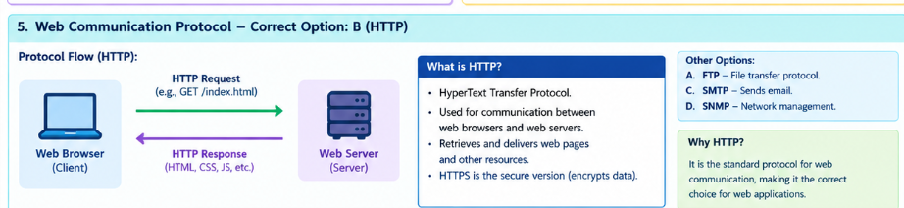

Conclusion
The case study explains how HTML, HTTP methods, semantic elements, XML, and communication protocols are used in web application development. The <video> tag embeds videos, POST submits registration data, <nav> organizes navigation links, valid XML syntax ensures structured data is well formed, and HTTP supports communication between browsers and web servers. Using these standards helps developers build well-structured and reliable web applications.

